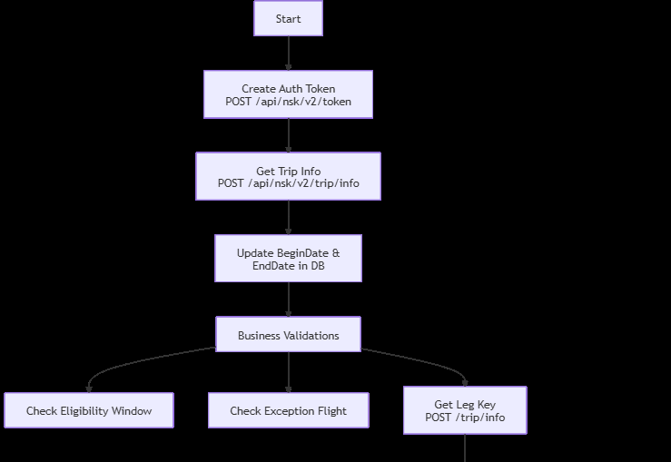
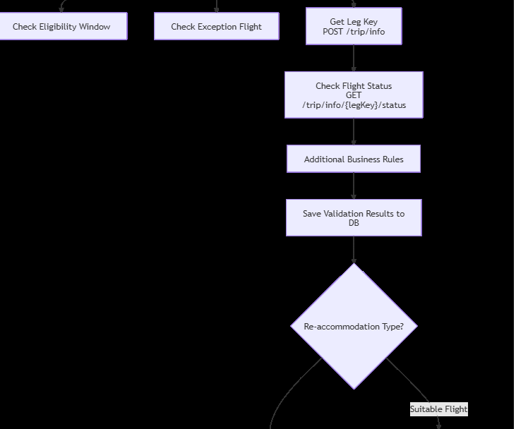
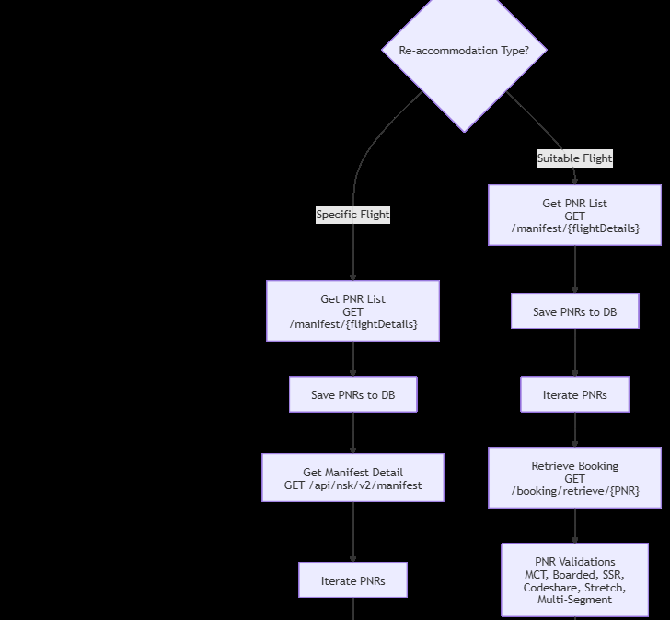
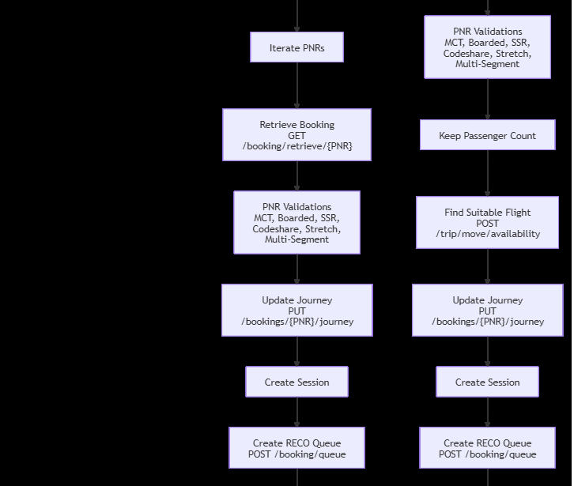
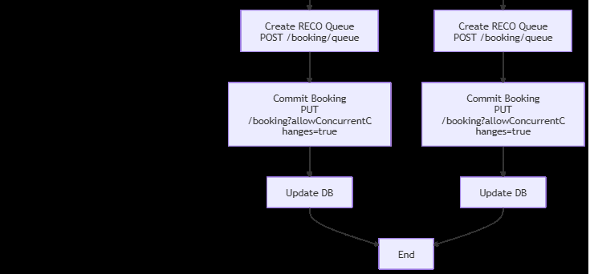

Flight Re-accommodation Flow – Navitaire Integration
This document describes the end-to-end flow for flight validation and re-accommodation using Navitaire APIs. It covers pre-checks, business validations, and two re-accommodation scenarios:
- Re-accommodate to a Specific Flight
- Re-accommodate to a Suitable Flight

1. Authentication

Step 1: Create Auth Token
Obtain a security token to access Navitaire APIs.
POST /api/nsk/v2/token

2. Trip Information & Date Validation

Step 2: Retrieve Flight Begin and End Dates
Fetch the flight’s BeginDate and EndDate.
POST /api/nsk/v2/trip/info

Step 3: Update Database
Update the local database with the BeginDate and EndDate returned from Navitaire.

3. Business Validation Checks

Step 4: Perform Business Rule Validations
a. Eligibility Checks
- CheckEligibilityWindow
b. Exception Handling
- CheckExceptionFlight
c. Navitaire Flight Status Validation
- Retrieve Leg Key
- POST /api/nsk/v2/trip/info
- Check Flight Status Using Leg Key
- GET /api/nsk/v2/trip/info/{legKey}/status
d. Additional Business Logic
- Apply any additional internal business rules
e. Persist Results
- Save or update validation results in the database

4. Re-Accommodation Flows
There are two possible re-accommodation scenarios:
- A. Reaccommodate to a Specific Flight
- B. Reaccommodate to a Suitable Flight

A. Reaccommodate to a Specific Flight

Step 5: Retrieve PNR List for the Selected Flight
Fetch all PNRs associated with the impacted flight.
GET /api/nsk/v1/manifest/{flightDetails}

Step 6: Store PNR Data
Save all retrieved PNR details into the database.

Step 7: Get Manifest Details (for Move PNR Operation)
Retrieve detailed manifest data for the given flight.
GET /api/nsk/v2/manifest?
Origin={}&
Destination={}&
CarrierCode={}&
BeginDate={}&
Identifier={}&
FlightType={}

Step 8: PNR-Level Iteration
Process each PNR individually.

Step 9: Retrieve Booking Details
Get full booking information for the PNR.
GET /api/nsk/v1/booking/retrieve/byRecordLocator/{PNR}

Step 10–17: Validation & Business Logic per PNR
- Handle Single Journey and Multiple Journey scenarios
- Validate MCT (Minimum Connection Time)
- Check Boarded Status
- Validate Multi-Segment Journeys
- Check Stretch PNR
- Check Code-Share Flights
- Validate SSR (Special Service Requests)
- Execute HandleUndoCheckingTask

Step 18: Update the Journey
Apply re-accommodation changes to the booking.
PUT /api/nsk/v1/bookings/{PNR}/journey

Step 19: Create Current Session
Initialize the booking session.

Step 20: Create RECO Queue
Create a re-accommodation queue entry.
POST /api/nsk/v2/booking/queue

Step 21: Commit the Booking
Finalize and commit booking changes.
PUT /api/nsk/v3/booking?allowConcurrentChanges=true

Step 22: Persist Final Data
Update all relevant booking and journey details in the database.

B. Reaccommodate to a Suitable Flight

Step 5: Retrieve PNR List for the Original Flight
GET /api/nsk/v1/manifest/{flightDetails}

Step 6: Store PNR Data
Save all PNR information in the database.

Step 7–8: PNR-Level Iteration
Process bookings PNR by PNR.

Step 9: Retrieve Booking Details
GET /api/nsk/v1/booking/retrieve/byRecordLocator/{PNR}

Step 10–17: Validation & Business Logic per PNR
- Handle Single and Multiple Journeys
- Validate MCT
- Check Boarded Status
- Validate Multi-Segment Journeys
- Check Stretch PNR
- Validate Code-Share Flights
- Validate SSR
- Execute HandleUndoCheckingTask

Step 18: Passenger Count Handling
Preserve and validate passenger count for suitable flight selection.

Step 19: Retrieve Journey Key for Suitable Flight
Find availability and journey key for the most suitable flight.
POST /api/nsk/v3/trip/move/availability

Step 20: Update the Journey
Apply the new suitable flight to the booking.
PUT /api/nsk/v1/bookings/{PNR}/journey

Step 21: Create Current Session

Step 22: Create RECO Queue
POST /api/nsk/v2/booking/queue

Step 23: Commit the Booking
PUT /api/nsk/v3/booking?allowConcurrentChanges=true

Step 24: Persist Final Data
Save updated booking, journey, and re-accommodation details in the database.

